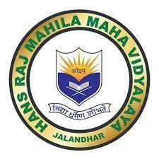
7.1.11
Institution Celebrates National and International days, events and festivals
LNIK FOR GEO TAGGED PHOTOGRAPHS
https://docs.google.com/spreadsheets/d/1OANeqGUstJ47HbhmRPEOTf8uNsLOX1QVLJn66nsAO3E/edit?usp=drivesdk

